Họ và tên: Nguyễn Minh Công

Lớp: DV19_MSSV: 1951040001

Câu 3)

a)

SELECT SUM(commission), city FROM salesman GROUP BY city

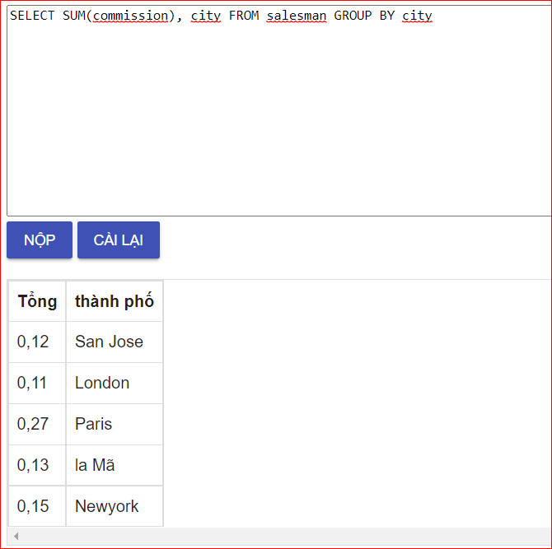

Câu 3b)

select * from customer c

join salesman s on c.salesman_id = s.salesman_id

where s.commission > 0.12

order by s.commission

